________________________________________________________

IT7742. Assessment 1
Analysis & Prototyping

Tarun (ID - 20231095)
________________________________________________________

UML Diagram Design Report

UML Diagram Report
________________________________________________________

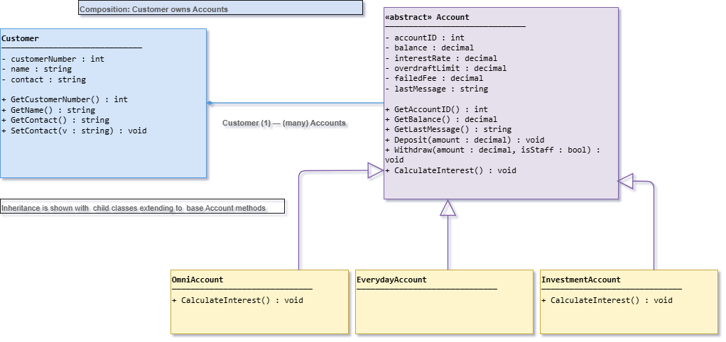
This diagram shows how customers and different types of accounts are connected, and how inheritance and abstraction are used in the design.
At the top left, the Customer class stores basic information about a person using the system. It has attributes like customer number, name, and contact. It also has getter and setter methods to access or change these details. The small diamond arrow between Customer and Account means that one customer owns or controls one or more accounts. This is called composition because accounts depend on the customer’s existence. In other words, if the customer is deleted, their account is also deleted.
The Account class is marked as abstract. This means one cannot create an Account object directly. Instead, it only provides a general template that all other account types will follow. It contains all shared features like account ID, balance, interest rate, overdraft limit, and failed transaction fee. The abstract class also defines common methods such as deposit, withdraw, and calculate interest. These methods guide the main money-handling logic used by all account types. The subclasses of account are OmniAccount, EverydayAccount, and InvestmentAccount and they are like extensions of the base Account class. All subclasses inherit the common methods from Account but change only when interest is calculated. Overall, this design shows inheritance.

